Plan of approach

group A

**Name: Student Nr: Email:**

Mihael Druzeta 5367131 mihael.druzeta@student.nhlstenden.com

Mihaela Covali 5292891 mihaela.covali@student.nhlstenden.com

Timofei Arefev 5300428 timofei.arefev@student.nhlstenden.com

Daryl Genove 5264652 daryl.genove@student.nhlstenden.com

Peter Zlamala 5340012 peter.zlamala@student.nhlstenden.com

Erika Nicolau 5326745 erika.nicolau@student.nhlstenden.com

Jia Men Lam 5290201 jia.men.lam@student.nhlstenden.com

Introduction

This document outlines the projected milestones and deadlines of the **Smart Bag** project for each week. This document will describe deadlines and outcomes of each week, but at the same time, it will have some room for adjustments if necessary. Given the fact that modern projects are rarely completed by the deadlines in the set time, it is important to point out that this Project plan was developed with the understanding that the Covali group will meet some unpredictable obstacles. This means that the document contains slightly stricter deadlines, so the team was able to adjust everything to meet the goal by the set time.

Week 1

This week’s main goal was to organize the team’s working environment and come up with the project idea.

The goals:

* Came up with an idea for the project.
* Prepare the necessary documentation to present the project.
* Set a budget for the project.

Week 2

This week's main goal is to get the project approved. Because the working week is just 3 days this week will lack of big goals for the project.

The goals:

* The group approves the documentation and budget.
* Approve the project.

Week 3

This week’s main goal is to clarify the project’s objective and start to work on separate parts of the project like preparation of an app UI or basic hardware setup.

The goals:

* Organize a meeting with teachers to clarify the project’s objective.
* App UI as a website (After that the website will be turned into the app).
* Basic setup of the hardware (All components of the system should function properly).

Week 4

This week’s main goal is to start working on the separate parts of the project. One group will work on the app and its UI, while the other will continue to work on hardware. This week's outcome should be an app with a working UI and NFC tracker that can send the information to Raspberry Pi.

The goals:

* Turning website UI into a basic app.
* Basic implementation of item tracking with Raspberry Pi.

Week 5

This week’s main goal is to have several main systems ready to connect in the next week. At the end of week 5, the app should be able to add or remove items, while Raspberry Pi should have a working prototype of tracking if an item is near or not.

The goals:

* Creation of a backend that will allow the app to track the items in the bag (no connection to the bag is necessary).
* Item tracking with Raspberry Pi should be finished (no connection to the app is necessary).

Week 6

At the end of this week, all the essential parts of the project should be finished. However, this week can also be used as a week for finishing all unfinished parts of the project.

The goals:

* Finish all parts of the project that were overlooked or unfinished.
* App to bag connection system
* Notification system

Week 7

This week is for finishing all the unfinished parts of the project. This week can help to fix some bugs or some parts of the project that were not done on time because of unexpected problems.

The goals:

* Polishing the product
* Bug fix

Week 8

This week serves as the final quality check for the product. All parts of the project should be finished, and big bugs should be fixed. This week the team should prepare a product to present it to other people.

The goals:

* Polishing the product
* Bug fix
* Preparing the final product

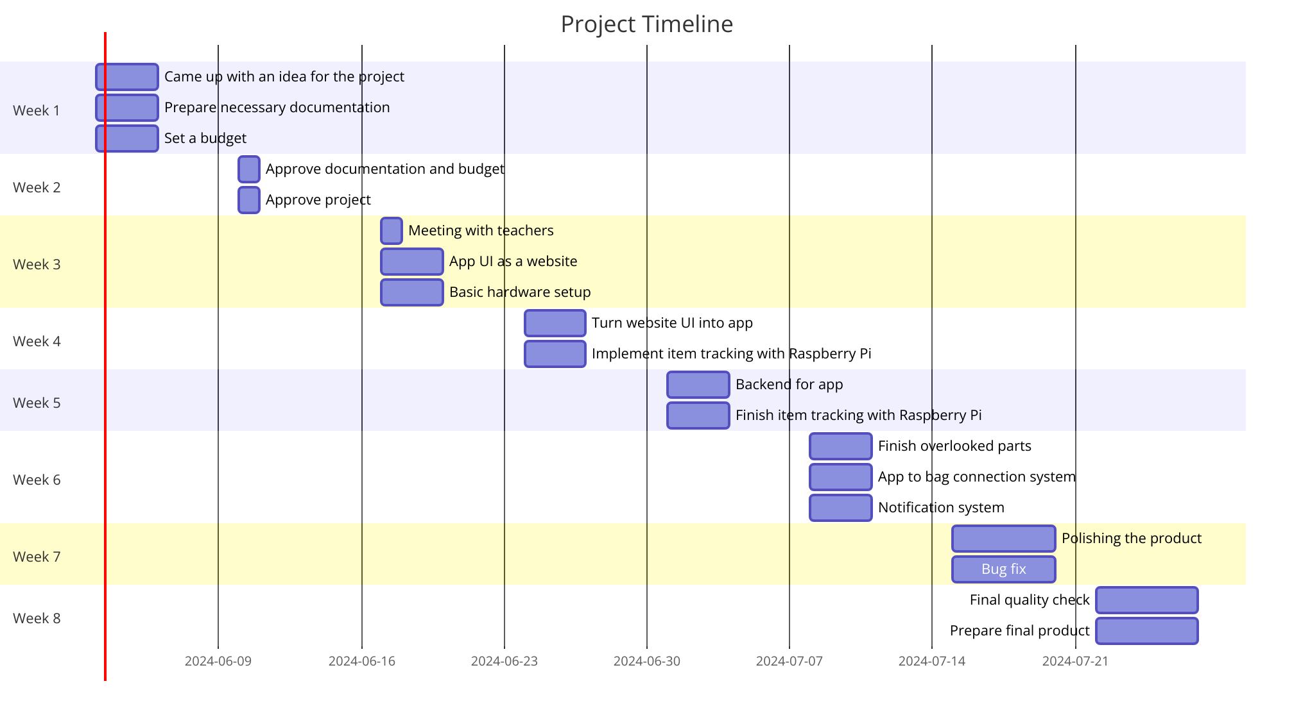

*Represantation of the time schedule as a Ganttchart*